Implementation

Part-1

1. Create API
   1. Use JSON file which contains various products details such as product_id, product_name, product_type, product_image, product_quantity, product_cost and description.
   2. Create 5 products sets in JSON.
2. Display all product information on console and also on client browser. [ Create server first]
3. Define following routes to access page.
   1. localhost/ [Bydefault display default page as below]
   2. localhost/default
   3. localhost/api
   4. localhost/product
   5. localhost/product?id=0 [By default]
   6. localhost/anyother then display page not found with status code.

Part-2 [HTML template/placeholder] - Define placeholder and replace by the content dynamically

1. Create HTML temples for 1. Default page 2. Product page and 3. CardInfo page
   1. Default page: Display products information from JSON such as ID, Name, Type and Price in different cards/sections [You may use DIV/FIGURE]
   2. Default page contain tag like **20% Discount**on some specific products.
   3. Default page contain link like **more details to** view individual product information [Display remaining info from JSON]
   4. All the individual product with respective cards should be accessible using URI like localhost/product?id=0 and so on.
   5. Use proper CSS style or any bootstrap theme.
2. Upload Instruction: PDF file with code and screenshots of each output.

**Index.js**

const fs = require('fs');

const http = require('http');

const url = require('url');

const replaceTemplate = (temp,product)=>{

let output = temp.replace(/{%name%}/g,product.name);

output = output.replace(/{%image%}/g,product.image);

output = output.replace(/{%quantity%}/g,product.quantity);

output = output.replace(/{%cost%}/g,product.cost);

output = output.replace(/{%description%}/g,product.description);

output = output.replace(/{%type%}/g,product.type);

output = output.replace(/{%id%}/g,product.id);

output = output.replace(/{%discount%}/g,product.discount);

if(!product.organic) output = output.replace(/{%NOT_ORGANIC%}/g, 'not-organic');

return output;

}

const tempOverview = fs.readFileSync(`${__dirname}/template-overview.html`, 'utf-8');

const tempCard = fs.readFileSync(`${__dirname}/template-card.html`, 'utf-8');

const tempProduct = fs.readFileSync(`${__dirname}/template-product.html`, 'utf-8');

const data = fs.readFileSync(`${__dirname}/data.json`, 'utf-8');

const dataObj = JSON.parse(data);

//Create Server

const server = http.createServer((req, res) => {

    //res.end(''hello from the server);

    //console.log(req.url);

    //console.log(url.parse(req.url, true));

    const { query, pathname } = url.parse(req.url, true);

    //const pathName = req.url;

    // Overview page

    if(pathname === '/' || pathname === '/default'){

        //res.end('This is OVERVIEW');

        res.writeHead(200, { 'Content-type': 'text/html'})

        const cardsHtml = dataObj.map(el => replaceTemplate(tempCard, el));

        //console.log(cardsHtml);

        const output = tempOverview.replace('{%product-cards%}', cardsHtml);

        //res.end(tempOverview);

        res.end(output);

    // Product page

    } else if (pathname === '/product'){

        res.writeHead(200, { 'Content-type': 'text/html'});

        const product = dataObj[query.id];

        const output = replaceTemplate(tempProduct, product);

        //console.log(query);

        //res.end('This is the Product!');

        res.end(output);

    // API page

    }else if(pathname === '/api'){

        res.writeHead(200, { 'Content-type': 'application/json' })

        res.end(data);

    // Not found

    }else{

        res.writeHead(404,{

            'Content-type': 'text/html',

            'my-own-header': 'hello-world'

        });

        res.end('<h1>Page not found!</h1>');

    }

});

// Server Listening

server.listen(8000, '127.0.0.1', ()=>{

    console.log('Listening request on port 8000');

});

**data.json**

[

    {

        "id": 0,

        "name": "kiwis",

        "type": "fruite",

        "image": "🥝",

        "quantity": "4 🥝",

        "cost": "6.50",

        "discount": "20%",

        "description": "hello i am mrs.Kiwi"

    },

    {

        "id": 1,

        "name": "lemons",

        "type": "fruite",

        "image": "🍋",

        "quantity": "4 🍋",

        "cost": "6.50",

        "discount": "--",

        "description": "hello i am mrs.lemons"

    },

    {

        "id": 2,

        "name": "pears",

        "type": "fruite",

        "image": "🍐",

        "quantity": "4 🍐",

        "cost": "6.50",

        "discount": "20%",

        "description": "hello i am mr.pears"

    },

    {

        "id": 3,

        "name": "tomatoes",

        "type": "fruite",

        "image": "🍅",

        "quantity": "4 🍅",

        "cost": "6.50",

        "discount": "--",

        "description": "hello i am mr.tomatoes"

    },

    {

        "id": 4,

        "name": "cheries",

        "type": "fruite",

        "image": "🍒",

        "quantity": "4 🍒",

        "cost": "6.50",

        "discount": "20%",

        "description": "hello i am miss.cherries"

    }

]

**template-overview.html**

<!DOCTYPE html>

<html lang="en">

<head>

    <meta charset="UTF-8">

    <meta http-equiv="X-UA-Compatible" content="IE=edge">

    <meta name="viewport" content="width=device-width, initial-scale=1.0">

    <title>Document</title>

    <style>

        *,

        *::before,

        *::after {

          margin: 0;

          padding: 0;

          box-sizing: inherit;

        }

        html {

          font-size: 62.5%;

          box-sizing: border-box;

        }

        body {

          padding: 5rem 5rem 10rem;

          line-height: 1.7;

          font-family: 'Nunito Sans', sans-serif;

          color: #555;

          min-height: 100vh;

          /* background: linear-gradient(to bottom right, #9be15d, #00e3ae); */

          background: linear-gradient(to bottom right, #5d8be1, #aaf9fc);

        }

        h1 {

          font-family: 'Megrim', sans-serif;

          font-size: 6rem;

          color: white;

          transform: skewY(-5deg);

          text-align: center;

          position: relative;

          word-spacing: 3px;

        }

        h1::before {

          content: '';

          display: block;

          height: 65%;

          width: 49%;

          position: absolute;

          top: 105%;

          left: 50%;

          background: linear-gradient(to bottom, #5d8be1, #aaf9fc);

          opacity: 0.8;

          z-index: -1;

          transform: skewY(370deg) translate(-50%, -50%);

        }

        .container {

          width: 95rem;

          margin: 0 auto;

        }

        .cards-container {

          margin-top: 8rem;

        }

        .card {

          background: white;

          box-shadow: 0 2rem 6rem 1rem rgba(0, 0, 0, 0.15);

          margin-bottom: 5rem;

          transform: skewX(-20deg);

          display: flex;

          transition: all 0.5s;

        }

        .card__emoji {

          font-size: 5.5rem;

          line-height: 1.2;

          padding: 1.5rem 6rem 0.5rem 1.5rem;

          letter-spacing: -4rem;

          transform: skewX(20deg);

        }

        .card__title-box {

          background: linear-gradient(to bottom, #9be15d, #00e3ae);

          margin-right: auto;

          display: flex;

          align-items: center;

          padding: 0 3rem;

        }

        .card__title {

          font-family: 'Megrim', sans-serif;

          color: white;

          font-size: 3.25rem;

          transform: skewX(20deg);

        }

        .card__details {

          display: flex;

        }

        .card__detail-box {

          align-self: stretch;

          border-right: 1px solid #ddd;

          display: flex;

          align-items: center;

        }

        .card__detail-box:last-child {

          border: none;

        }

        .card__detail {

          font-weight: 400;

          font-size: 1.8rem;

          transform: skewX(20deg);

          padding: 1.75rem;

        }

        .card__detail--organic {

          font-weight: 900;

          text-transform: uppercase;

          font-size: 1.9rem;

          background-image: linear-gradient(to right, #9be15d, #00e3ae);

          -webkit-background-clip: text;

          background-clip: text;

          color: transparent;

        }

        .card__detail--price {

          font-weight: 900;

          font-size: 1.9rem;

        }

        .card__link:link,

        .card__link:visited {

          flex: 0 0 auto;

          background-color: #79e17b;

          color: white;

          font-size: 1.6rem;

          font-weight: 900;

          text-transform: uppercase;

          text-decoration: none;

          padding: 2.5rem;

          text-align: center;

          display: flex;

          align-items: center;

          justify-content: center;

          transition: all 0.3s;

        }

        .card__link:hover,

        .card__link:active {

          background-color: #9be15d;

        }

        .card__link span {

          transform: skewX(20deg);

        }

        .card:hover {

          transform: skewX(-20deg) scale(1.08);

          box-shadow: 0 3rem 8rem 2rem rgba(0, 0, 0, 0.15);

        }

        .emoji-left {

          font-size: 2rem;

          margin-right: 1rem;

        }

        .emoji-right {

          font-size: 2rem;

          margin-left: 1rem;

        }

        .not-organic {

          display: none;

        }

      </style>

</head>

<body>

    <div class="container">

        <h1>🥬 Node mart 🍒</h1>

    <div class="cards-container">

        {%product-cards%}

    </div>

</div>

</body>

</html>

**template-product.html**

<!DOCTYPE html>

<html lang="en">

<head>

    <meta charset="UTF-8">

    <meta http-equiv="X-UA-Compatible" content="IE=edge">

    <meta name="viewport" content="width=device-width, initial-scale=1.0">

    <title>{%name%} {%image%}</title>

    <style>

        *,

        *::before,

        *::after {

          margin: 0;

          padding: 0;

          box-sizing: inherit;

        }

        html {

          font-size: 62.5%;

          box-sizing: border-box;

        }

        body {

          padding: 5rem 5rem 10rem;

          line-height: 1.7;

          font-family: 'Nunito Sans', sans-serif;

          color: #555;

          min-height: 100vh;

          background: linear-gradient(to bottom right, #5d8be1, #aaf9fc);

        }

        h1 {

          font-family: 'Megrim', sans-serif;

          font-size: 6rem;

          color: white;

          transform: skewY(-5deg);

          text-align: center;

          position: relative;

          word-spacing: 3px;

        }

        h1::before {

          content: '';

          display: block;

          height: 65%;

          width: 49%;

          position: absolute;

          top: 105%;

          left: 50%;

          background: linear-gradient(to bottom, #5d8be1, #aaf9fc);

          opacity: 0.8;

          z-index: -1;

          transform: skewY(370deg) translate(-50%, -50%);

        }

        .container {

          width: 95rem;

          margin: 0 auto;

        }

        .product {

          width: 60rem;

          margin: 0 auto;

          margin-top: 9rem;

          background: white;

          box-shadow: 0 3rem 6rem 1rem rgba(0, 0, 0, 0.2);

          position: relative;

        }

        .product__hero {

          position: relative;

          height: 22rem;

          overflow: hidden;

        }

        .product__hero::before {

          content: '';

          display: block;

          height: 100%;

          width: 100%;

          position: absolute;

          top: 0;

          left: 0;

          background-image: linear-gradient(to left bottom, #9be15d, #00e3ae);

          opacity: 0.5;

          z-index: 100;

        }

        .product__emoji {

          font-size: 15rem;

          position: absolute;

        }

        .product__emoji--1 {

          top: -4rem;

          left: -2rem;

          z-index: 10;

        }

        .product__emoji--2 {

          top: -6rem;

          left: 9rem;

        }

        .product__emoji--3 {

          top: -4rem;

          right: 15rem;

        }

        .product__emoji--4 {

          top: -5rem;

          right: 2rem;

          z-index: 10;

        }

        .product__emoji--5 {

          bottom: -9rem;

          left: 18rem;

        }

        .product__emoji--6 {

          bottom: -8rem;

          left: 5rem;

        }

        .product__emoji--7 {

          bottom: -12rem;

          right: 14rem;

        }

        .product__emoji--8 {

          bottom: -8rem;

          right: -2rem;

        }

        .product__emoji--9 {

          top: -7rem;

          left: 19rem;

        }

        .product__organic {

          position: absolute;

          top: -4rem;

          right: -4rem;

          z-index: 1000;

          height: 11rem;

          width: 11rem;

          background-image: linear-gradient(to bottom, #9be15d, #00e3ae);

          border-radius: 50%;

          transform: rotate(15deg);

          box-shadow: 0 2rem 4rem rgba(0, 0, 0, 0.4);

          display: flex;

          align-items: center;

          justify-content: center;

        }

        .product__organic h5 {

          font-weight: 900;

          text-transform: uppercase;

          font-size: 1.8rem;

          color: white;

        }

        .product__back:link,

        .product__back:visited {

          position: absolute;

          top: 2rem;

          left: 2rem;

          font-size: 1.5rem;

          font-weight: 700;

          text-transform: uppercase;

          text-decoration: none;

          z-index: 1000;

          color: #555;

          background-color: white;

          box-shadow: 0 1rem 3rem rgba(0, 0, 0, 0.3);

          border-radius: 100rem;

          padding: 0 2rem;

          transition: all 0.3s;

          display: flex;

          align-items: center;

        }

        .product__back:hover,

        .product__back:active {

          background-color: #79e17b;

        }

        .product__name {

          background: linear-gradient(to bottom, #9be15d, #00e3ae);

          padding: 1rem;

          font-family: 'Megrim', sans-serif;

          font-size: 4rem;

          color: white;

          text-align: center;

          word-spacing: 2px;

        }

        .product__details {

          background-color: #eee;

          padding: 4rem 6rem;

          font-size: 1.9rem;

          display: grid;

          grid-template-columns: 1fr 1fr;

          grid-gap: 1.5rem;

        }

        .product__description {

          padding: 5rem 6rem;

          font-size: 1.9rem;

          line-height: 1.8;

        }

        .product__link:link,

        .product__link:visited {

          display: block;

          background-color: #79e17b;

          color: white;

          font-size: 1.6rem;

          font-weight: 700;

          text-transform: uppercase;

          text-decoration: none;

          padding: 1.5rem;

          text-align: center;

          transform: scale(1.07) skewX(-20deg);

          box-shadow: 0 2rem 6rem rgba(0, 0, 0, 0.2);

          display: flex;

          align-items: center;

          justify-content: center;

          transition: all 0.3s;

        }

        .product__link:hover,

        .product__link:active {

          background-color: #9be15d;

          transform: scale(1.1) skewX(-20deg);

        }

        .product__link span {

          transform: skewX(20deg);

        }

        .emoji-left {

          font-size: 2rem;

          margin-right: 1rem;

        }

        .emoji-right {

          font-size: 2rem;

          margin-left: 1rem;

        }

        .not-organic {

          display: none;

        }

      </style>

</head>

<body>

    <div class="container">

        <h1>🥬 Node mart 🍒</h1>

        <figure class="product">

            <div>

                <h3>Organic</h3>

            </div>

            <a href="/default" class="product__back">

            <span class="emoji-left">👈</span>Back

            </a>

            <div class="product__hero">

                <span class="product__emoji product__emoji--1">{%image%}</span>

                <span class="product__emoji product__emoji--2">{%image%}</span>

                <span class="product__emoji product__emoji--3">{%image%}</span>

                <span class="product__emoji product__emoji--4">{%image%}</span>

                <span class="product__emoji product__emoji--5">{%image%}</span>

                <span class="product__emoji product__emoji--6">{%image%}</span>

                <span class="product__emoji product__emoji--7">{%image%}</span>

                <span class="product__emoji product__emoji--8">{%image%}</span>

                <span class="product__emoji product__emoji--9">{%image%}</span>

            </div>

            <h2 class="product-name">{%name%}</h2>

            <div>

                <p><span class="emoji-left">🌎</span>type {%type%}</p>

                <p><span class="emoji-left">❤️</span>{%quantity%}</p>

                <p><span class="emoji-left">📦</span>{%cost%}</p>

            </div>

            <a href="#" class="product__link">

                <span class="emoji-left">🛒</span>

                <span>Add to shopping cart ({%cost%})</span>

            </a>

            <p class="product__discription">

                {%description%}

            </p>

        </figure>

    </div>

</body>

</html>

**template-card.html**

        <figure class="card">

            <div class="card__emoji">

                {%image%}{%image%}

            </div>

            <div class="card__title-box">

                <h2 class="card__title">{%name%}</h2>

            </div>

            <div class="card__details">

                <div class="card__detail-box">

                    <h6 class="card__detail card__detail--organic">

                        Organic!

                    </h6>

                </div>

                <div class="card__detail-box">

                    <h6 class="card__detail">{%quantity%} per 📦</h6>

                </div>

                <div class="card__link">

                    <h6 class="card__detail card__detail--price"> {%cost%} $ </h6>

                    <h6 class="card__detail card__detail--price"> discount:{%discount%}</h6>

                </div>

            </div>

            <a class="card__link" href="/product?id={%id%}">

                <span>Detail <i class="emoji-right">👈</i></span>

            </a>

        </figure>

**OUTPUT**

**localhost/api**

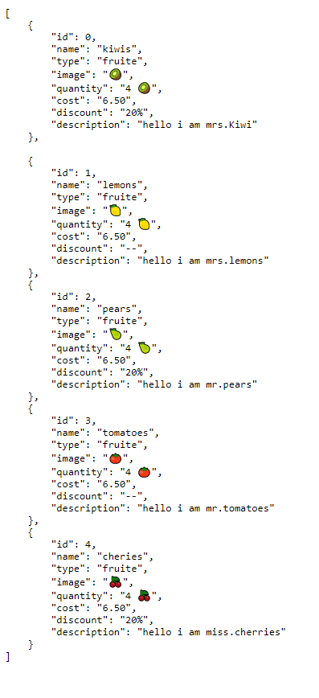

**localhost:8000/default**

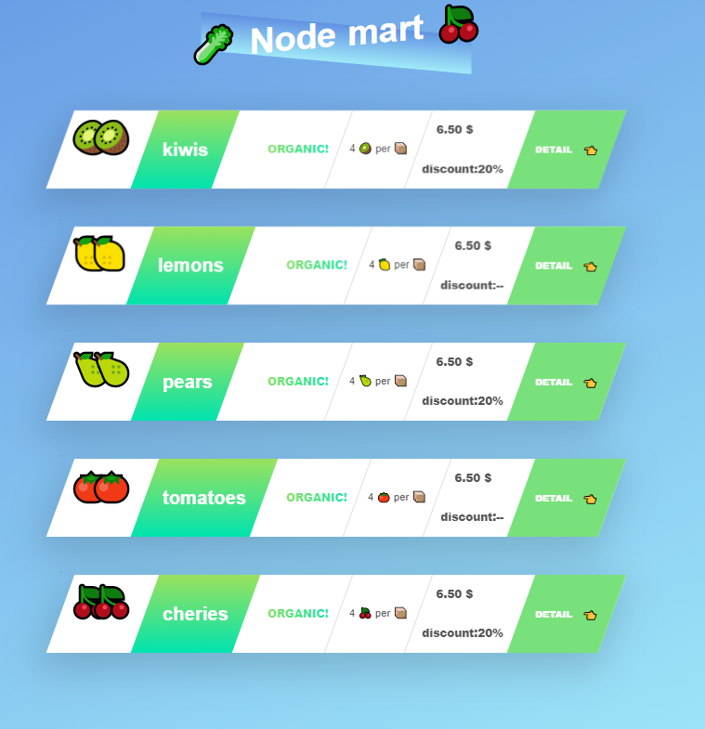

**localhost:8000/product?id=0**

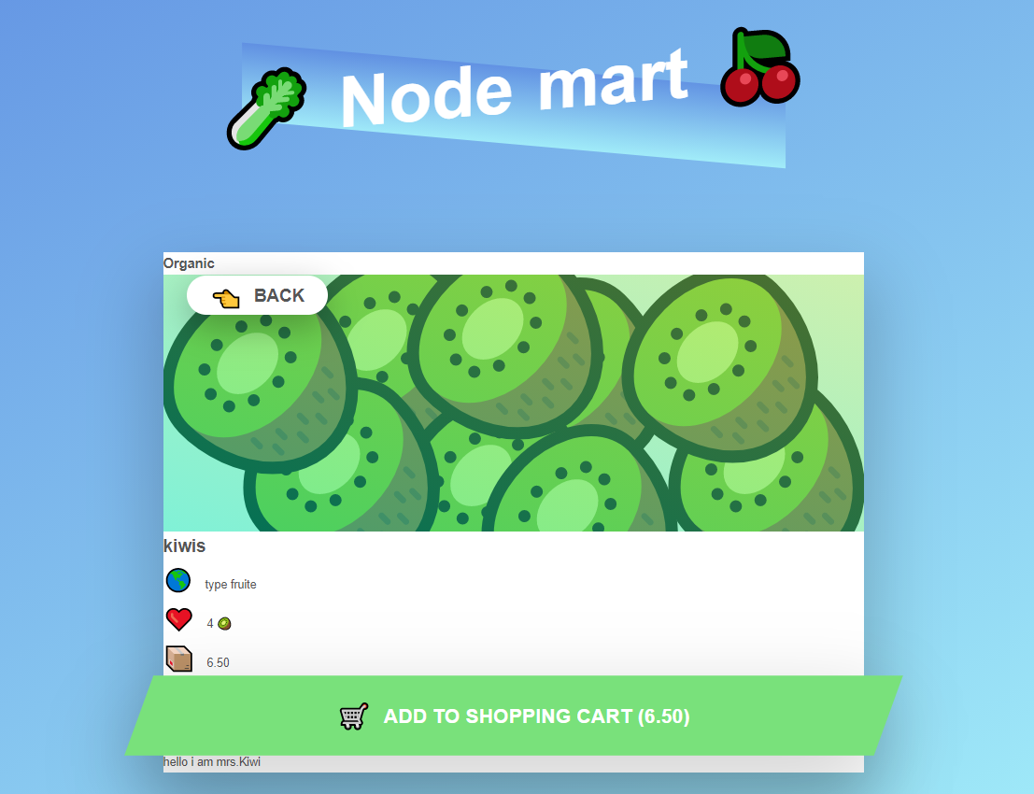

**localhost:8000/product?id=1**

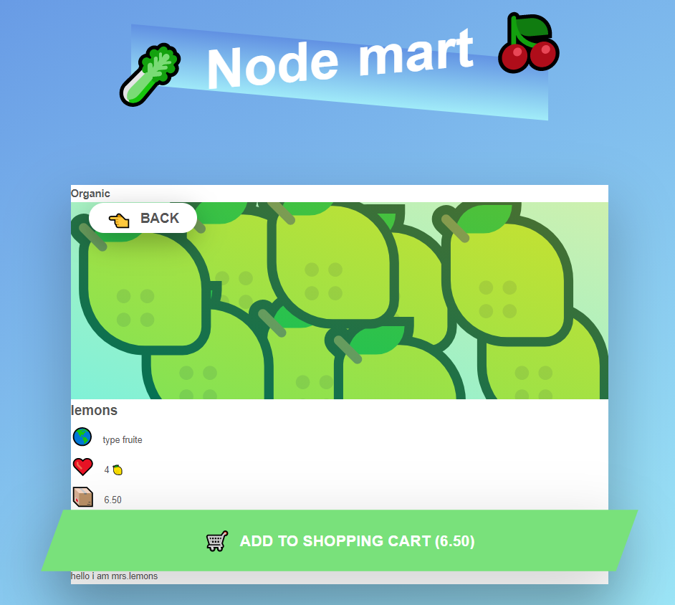

**localhost:8000/product?id=2**

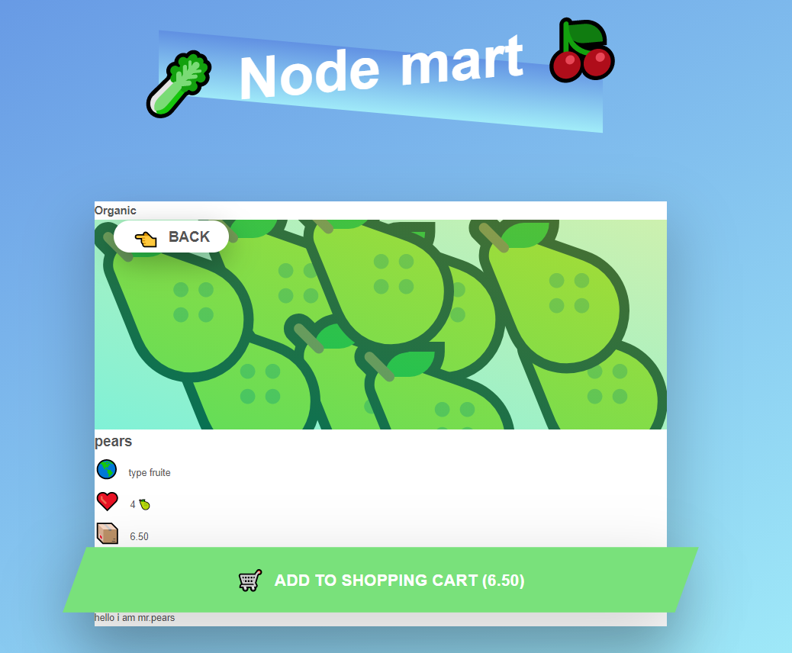

**localhost:8000/product?id=3**

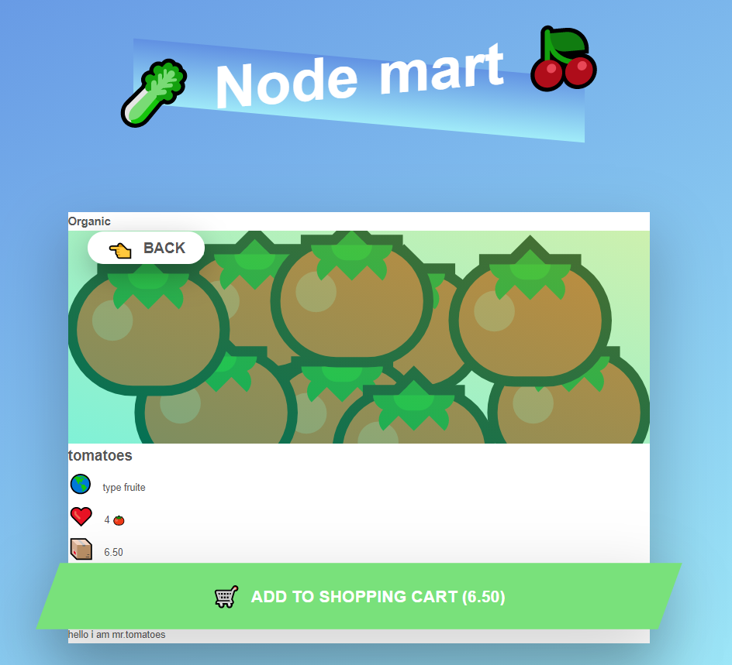

**localhost:8000/product?id=4**

